

Prepared in 2011 by:

Shani D. Carter
Professor, Management & Marketing

With input from:
Jeffrey Blais, Economics and Finance
Jason Blank, Sociology; President, RIC/AFT 1819
Karen Castagno, Feinstein School of Education and Human Development
Desirée Ciambrone, Sociology
Patricia Cordeiro, Elementary Education
Monica Darcy, Counseling, Educational Leadership, and School Psychology
Susan Dell, Special Education
David Filipek, Accounting and Computer Information Systems
Eric Hall, Biology
Michael Hayden, Health Care Administration
Raimundo Kovac, Mathematics and Computer Science
Yolande Lockett, School of Nursing
Pierre Morenon, Anthropology
Scott Mueller, BSW Program
Jayashree Nimmagadda, MSW Program
Ronald Pitt, Academic Affairs
Betty Rauhe, Health and Physical Education
Maureen Reddy, English
Glenn Rawson, Philosophy
Kathryn Sanders, Mathematics and Computer Science

Table of Contents
OPENING STATEMENT 6
(1) Being a Caring Chair 6
SECTION 1: GENERAL ISSUES 8
(1) Frequent Contacts 8
(1) Frequent Contacts 8
(2) Startup issues 9
Get chair access to PeopleSoft 9
Access to transcripts with financial hold 10
Interview all faculty 10
Contact student clubs to see their status 10
Internalize role as chair 10
(3) Calendar 11
(4) Staff Supervision 14
(4) Department Marketing 15
Web site 15
Mandatory Information 15
Other Helpful Information 15
Brochures 15
Offices that may be able to provide assistance 15
(5) Budget 16
(6) Department Meetings 17
Schedule 17
Agenda 17
(7) Chair Election 18
(8) RIC Policies 19
College Handbook – Chapter 3 – Academic Policies, Grade Appeals 19
Student Handbook 19
Complaint Resolution Policy 19
Illegal Harassment Policy 19
(9) Accreditation 20
NEASC 20
Other Accreditations 20
(10) Curriculum 21
Undergraduate Curriculum 21
Graduate Curriculum 21
Assessment 21
(11) Rental and Use of College Facilities: EMS 22
Room Reservations 22
Electornic Classrooms 22
(12) Favorite Queries 23
Reporting tools, Query, Query Viewer 23
Your department name 23
Semesters are 23
Search for a query 23
Add a query to your “favorites” 23
list of favorite queries 24
SECTION 2: STUDENT ISSUES 25
(1) Course Substitutions 25
Transcript notations. 25
If the student took the class at RIC. 25
Course Substitution form 25
General Education Course Substitution 25
If the student took the class at another college. 25
Transfer Credit Report. 26
Review the courses 26
(2) Transfer Guide, RIBGHE 27
Annual Meeting 27
CCRI to RIC 27
Bristol CC to RIC 27
(3) Class Search 28
General Education 28
(4) Academic Advising 29
Find students to advise, and manage the number of students per professor 29
Create a one-page or two-page advising form 29
Sample advising forms 29
The advising form should include: 29
Hold an advising meeting. 29
Obtain the Academic Advising Transcript 29
Check the student’s progress in meeting requirements 29
Advise student on next steps 30
(5) FERPA 31
(6) Majors and Minors 32
Advisors 32
Query for advisors 32
Query for students without an advisor 32
Management & Marketing minor 32
(7) Add students into classes 34
(8) Dropping a Class / “W” Grades 36
(9) Add / Drop Research: student & course enrollment history 37
Student enrollment history 37
Course enrollment history 39
(10) Departmental Honors 40
(11) Departmental Awards 41
Graduation Awards 41
Graduation Query 41
Alumni Awards 41
Scholarships 41
(12) Graduation 42
Applying for graduation 42
Graduation query / list of graduates 42
(13) Second Degree Students 43
SECTON 3: FACULTY ISSUES 44
(1) DAC 44
Article VI (RIC/AFT 1819). 44
Structure of the DAC 44
Duties of the DAC 44
Article VI (RIC/AFT 1819). 44
(2) Special Events 45
Summer 45
Fall 45
Spring 45
(3) Class Roster 46
(4) Book Orders 47
RIC Bookstore Orders 47
(5) Building Schedules 48
The process 48
Run the Query 48
Format the spreadsheet 48
Update the spreadsheet 49
Submit to Records Office 49
(6) Adjuncts 50
Adjunct union contract 50
Promotion: Level Advancement 50
Unsolicited resumes 51
(7) Faculty Workload 52
The process 52
Step 1: Add faculty to classes 52
To change a class to “staff 52
Step 2: Complete workload forms in Peoplesoft 54
Review your work: summary of compensaton 56
Review your work: workload details for each professor 58
Step 3: Submit payroll 60
Chair compensation 60
Faculty compensation 60
(8) Annual Reviews 62
The Process 62
Critera 62
Teaching effectiveness 62
Professional competence 62
Documentation 62
Peer Observation / Classroom Observation Report 62
Student Course Evaluations 62
Faculty Personal Data Form 62
Other Documentation 62
(9) Recruiting faculty 63
The process 63
Step 1: Submit a request 64
Step 2: Create the job description. 64
Step 3: Create the advertisement 64
Example of Chronicle advertisement 65
Step 4: Review applicants. 65
Step 5: Interview applicants. 66
Reimbursement 66
Hotel 66
Interview day schedule 66
Structured Interview Questions 66
Step 6: Submit a name for hire and recommended salary to the administration. 67
Section 4: Bibliography 68
General Resources 68
The Business of Chairing 68
Special Issues in Effective Chairing 69
Teaching 70
Useful Polemics on the state of higher ed. 70
Miscellaneous On-line Resources 70

Update Table of Contents F9
Mark item for Table of Contents: shift, alt, O

OPENING STATEMENT

(1) Being a Caring Chair

Dr. Maureen Reddy, chair of English, has this to say about the important leadership role that the chair fulfills:

“Welcome to your new position as department chair! The chair both sets the tone within the department and represents the department, and therefore the particular discipline, to the campus community and beyond. Much of the rest of this manual is about the nitty gritty, daily work of chairing—the forms you will have to fill out, the deadlines you will need to meet, the procedures you will need to follow, the campus offices that will be your lifeline—but we hope that you do not allow the volume of that information (or indeed the daily tasks themselves) to obscure the larger issues in chairing. No one becomes chair just to perform the housekeeping functions involved in the job, but it is easy to get swamped by those housekeeping functions and to lose sight of the reasons you wanted to become chair in the first place. Chairing offers an excellent opportunity to bring about changes that will improve the experiences of both students and faculty in your department. As chair, you can have a lasting, positive impact on your department and on the college through curricular development, faculty hiring and mentoring, recruitment of majors and minors, and a host of other possibilities. You cannot, however, do that without clear goals, nor can you do it alone, without support from your colleagues and from the administration. Take some time in your first term (or, ideally, the summer before you become chair) to gather information from your colleagues and from your dean and to use that information along with your own inclinations to set a few goals, even if quite modest ones, for the first year. Resolve both to involve as many members of the department as possible in the steps to achieving those goals and to work steadily on those goals yourself throughout the year. Say yes to college committee assignments that might help you achieve those goals. Talk to other chairs. Take advantage of any support for chairs your own discipline might offer (many professional organizations have chairs’ listserves, for instance). Recognize that you are an academic leader and take that responsibility at least as seriously as you take assigning advisors to students or signing faculty travel reports. Have fun, and enjoy being your department’s and discipline’s liaison to the rest of the college.”

The following table is reprinted, with permission from Sage Publications, from Kroth and Keeler (2009) Human Resource Development Review 8(4):506-531.
Manager (Carator) Behaviors
Invites Employees  Is receptive and fully available to the employee | Capacitizes Employees  Sees individual potential and helps employees grow and learn
Is emotionally accessible  Pays attention  Shows interest in the employee  Accepts the employee  Remains open to ideas, possibilities (is open-minded)  Empathizes | Informs employees  Facilitates problem-solving  Gives generative feedback  Encourages employees  Believes in employees  Teaches and mentors employees
Advances Employees  Has a desire to help the employee succeed | Connects with Employees
Puts employee plans/goals ahead of his/her own  Advocates for the employee  Commits to employee success  Protects employees  Seeks opportunities for advancing employees | Shares feelings  Develops relationships of mutual trust and obligation
Kroth, M. & Keeler, C. (2009). Caring as a Managerial Strategy. Human Resource Development Review, 8(4) 506-531. http://hrd.sagepub.com/content/8/4/506.full.pdf+html

SECTION 1: GENERAL ISSUES

(1) Contractual Information

Chairpersons’ duties and responsibilities are outlined in Article V, §5.1 of the Agreement between the RIC/AFT (Local 1819) and the Rhode Island Board of Governors. Throughout the contract, there are specific references to the above duties and responsibilities.

(2) Frequent Contacts

Topic | Position | Name | email
Budget | Budget specialist  Pre-audit clerk | Dawn Kenney  Ivone Rodrigues | dkenney@ric.edu  irodrigues@ric.edu
Payroll / finance | Senior accountant | Debby Iannuccilli | DIannuccilli@ric.edu
Records:  Schedules | Associate director | Dennis McGovern | DMcGovern@ric.edu
Records:  Graduation issues | Senior recorder/advisor  Senior recorder/advisor | Teresa Riley (A-K)  Janet Shumate (L-Z) | TRiley@ric.edu  JShumate@ric.edu
Human Resources | Associate director | Sullivan, Maggie | MSullivan@ric.edu
Human Resources:  Recruiting | Admin. secretary  Staff assistant  Recruitment manager | Sandra Langlois  Dorgan, Linda (EEO)  Janine Tegu (ads) | SLanglois@ric.edu  ldorgan@ric.edu  JTegu@ric.edu
PeopleSoft/MIS | Director  Programmer/analyst  Programmer/analyst | Bin Yu  Michael Macaulay  Ludmila Shalapyonok | MMacaulay@ric.edu  BYu@ric.edu  LShalapyonok@ric.edu
Scholarships | Financial coordinator  Accountant  College Advancement | Susan Iovini  Cathy Hanrahan | SIovini@ric.edu  CHanrahan@ric.edu
Book orders |  | Bookstore | textbooks@ric.edu
Web site | Director of Web Services | Karen Rubino | krubino@ric.edu

(3) Startup issues

Management Information Services
Management Information Services (MIS) provides technical support for all administrative functions at Rhode Island College. Within PeopleSoft, the department chairs have special access to certain functions and features.

In RIConnect (the college’s HR and Student Administrative System):

- Managing faculty activities through the RIC Management Center
  - Hiring adjunct faculty
  - Submitting adjunct instructor contracts
  - Assigning faculty courses
  - Managing faculty workload
- Managing student activities
  - Handling students’ requests for change-of-major
  - Managing advisors by assigning faculty advisors to students
  - Removing UADs for students
  - Processing special enrollment requests
  - Running transcript for students
  - Evaluating students’ enrollment summery
  - Accessing grade rosters and class rosters for faculty in special situations
- Performing administrative duties
  - Running special reports and queries for various administrative purposes.

In the college’s Financials System:

- Managing departmental budgets
- Managing POs
- Managing grants

MIS has the following supporting structure for all department chairs:

- You can schedule a special workshop with the MIS Help Desk by calling 9873 or emailing MISHelpDesk@ric.edu.
- Feel free to contact MIS Director (Bin Yu at 8160, or byu@ric.edu) for special requests such as special reports, queries, and/or features.

Get chair access to PeopleSoft
As chair, you will access to many additional areas in PeopleSoft that regular faculty do not see. Contact MIS to be granted this access.

Bin Yu BYu@ric.edu, Director of Management Information Services

Access to transcripts with financial hold
Normally, if the student has a financial hold, faculty cannot view the transcript, but the chair can ask to be granted this access. If you do not have this access, you can see some of a student’s record by viewing “Course History” instead of viewing “Transcript.”

Interview the faculty
Either before or shortly after assuming chair duties, meet with each professor in your department one-on-one in the faculty member’s office The purpose is to determine each faculty member’s goals, preferences, and perspectives that they may not have shared with you as a departmental colleague.

Contact student clubs to see their status
Shortly after assuming the duties of chair, contact departmental student clubs and their advisors. This contact is meant to familiarize you with the club’s activities and to determine whether the club needs resources.

Internalize role as chair
As chair, you are no longer in the role of a regular faculty member. As evaluator and mentor, your voice may carry more weight than it did previously, so it is important to use that role delicately and always strive to gain the input and opinions of all faculty members. As chair, it may be best for you to withhold your own personal opinions to faculty, staff, and students, because they may see your views as being the official department opinion.

(4) Calendar
The Administrative Calendar contains dates of relevance to department chairs:
http://www.ric.edu/administration/adminCalendar.php

Other items to include in calendar below:

Calendar developed by Kate Sanders and Raimundo M. Kovac
Approximate Date | Task
Fall Semester
August | Hire adjuncts
Second week of August | Final review of next spring’s schedule (page proofs)
Last week of August | Email fac re agenda items for dept mtg
Wed. before classes start | President’s opening coffee hour
Thurs. before classes start | FAS Dean’s opening meeting
Week before classes start | Make sure attendance forms are available for the Add/Drop period (unless/until they implement waiting lists in PeopleSoft)
Week before classes start | Start-of-semester email to faculty
Week before classes start | Appoint Elections Committee (2 faculty who are not running for DAC) to run DAC election
Week before classes start | Make sure all fac have tokens/ID access they need for classrooms (esp. new fac and adjuncts)
First two weeks of classes | Add/drops
First week of classes | Email fac asking who doesn’t want a final, and who wants single exam for multiple sections of same course
September
First week of September | Software requests for Spring
First week of September | Print faculty load forms and put in faculty boxes for comments
First week of September | Enter special monthly payroll into PeopleSoft for adjuncts and overloads, in order to meet end-of-September payroll
First week of September | DAC election
First week of September | Committee forms → fac
First week of September | Hire student help for office
First week of September (or when draft arrives from Records) | Course preference forms → fac for summer, fall of following year.
September | Committee assignments
Last week of September | Email fac re agenda items for Oct dept mtg
October
First week of October | Summer schedule due for following year
First week of October | Fall schedule due for following year.
First week of October | Faculty sabbatical requests due
Early October | Email students with preregistration / advising info
October | Spring book order forms to faculty
Mid-October | Mail fac w/instructions for midterm grades
Late October | Spring book order forms to bookstore
Last week of October | Email fac re agenda items for Nov dept mtg
November
November 1 | Faculty load info due (entered into PeopleSoft)
Second Saturday of November | Admissions Open House (Faculty Admissions Liaison attends)
Two weeks before Thanksgiving | Student evaluation forms to faculty
Before Thanksgiving | Student evaluation forms back from faculty. Bubblesheets to office for scanning; DAC needs results in early Dec. for fac evals.
Before Thanksgiving | Promotion/tenure folders (if any) to DAC
Before Thanksgiving | Discuss promotion/tenure cases informally with Dean
Before Thanksgiving | Revised summer schedule due
Last week in November | Email fac re agenda items for Dec dept mtg
December
December 1 | Deadline for faculty meeting for chair selection, if chair’s term is in third year
First week in December | End-of-semester email
First week in December | Faculty notified re sabbaticals; incorporate into scheduling
First week in December | Revised fall schedule due
First week in December | Fac eval portfolios to DAC; schedule mtgs
First week in December | Forward names of chair nominees to Dean (if term ending)
December | Make sure to get info from Dean with faculty info for eval forms (date of current position, etc.)
Third/fourth week in December | Exam week: be available in case there are problems with rooms, makeups, etc.
BREAK
January
Jan 1 | Deadline for curriculum changes to be signed off, in order to make the next catalog
Early January | Promotion/tenure folders due in Dean’s office with “extended evaluation” written by Chair
Early January | Graduate Open House – arrange departmental representation
January | Write annual evaluations for faculty
January | Make sure all majors have advisors in PeopleSoft
January | 2d draft of summer and fall schedules due
January | Hire adjuncts for spring
Mid-January | ***Alumni Award nominations due***
Week before classes start | Final proofread of summer and fall schedules
Week before classes start | Start-of-semester email
Week before classes start | Make sure attendance forms are available for add/drop period (unless/until they implement waiting lists on PeopleSoft)
Week before classes start | Post signs explaining waitlist policy
Week before classes start | Make sure all fac have whatever tokens/ID access they need for classrooms (esp. new fac and adjuncts)
Spring Semester
First two weeks of classes | Add/drop and waitlists
First/second week of classes | Welcoming reception
First week of classes | SMPs for adjuncts and overload forms due to Dean’s office
 | Faculty load forms printed and → fac for comments
First week of classes | Email fac asking who doesn’t want a final, and who wants single exam for multiple sections of same course
Last week in January | Email fac re agenda items for Feb dept mtg
February
February 1-14 | Faculty evaluations → Dean
February 28 | Assessment feedback due to DRC
February/March | Recruit summer chair(s)
March
March/April | Get lists of accepted students from Admissions and send out recruiting letters (email?)
First week in March | 1st draft of Spring schedule due for following year
March 7 | Look for and distribute summer contracts
March 15 | Honors project proposal deadlines (so we know in time to adjust the fall/spr scheds)
March 15 | DRC mtg re Howland/Mitchell/other – need time to meet w/honorees and do writeups before deadline (below)
Third week in March | Summer book orders to bookstore
Third week in March | Faculty load forms due
March 22 | Folders due for FAS research/teaching/service awards
March 24 | Email students with preregistration / advising info
March 24 | Faculty research proposals due
March 31 | Howland/Mitchell/elem award nominations due
April
First week in April | Fall book orders to bookstore
First Saturday in April | Admissions Spring Party for accepted students – Faculty Admissions Liaison attends
April 15 | Software requests for Fall due
April 21 | Requisition to College Lectures Committee for 06-07 funding
April 21 | Research release time requests → Dean for 06-07
April/May | 10 (plus or minus) breakfasts/lunches/dinners etc. to attend – try to delegate!
April/May | Submit hire request for full time faculty positions to be searched in the following academic year
April/May | Arrange departmental representation at summer orientation
May
Wednesday Free Period, last week of classes | Cap and Gown Day – arrange departmental representation
Third Saturday in May | Undergraduate Commencement
(5) Staff Supervision

Department staff are members of Council 94 and, as such, their employment is governed by the union contract. Most secretaries fill the position of clerk/typist.

(6) Department Marketing

Web site
Chairs are responsible for keeping the department web site up to date.
Contact Web Service, Karen Rubino, at <KRubino@ric.edu>

Mandatory Information
Program information
Overall program description and learning goals for students
Course requirements
Courses
Course descriptions
Faculty
Name, office, phone, email, academic background, areas of specialization, courses taught
Program goals
Learning outcomes used for outcomes assessment.

Other Helpful Information
Honors Program/Awards
If department has an Honors program.
Careers & Internships
Departmental & RIC Internship & Career information.
Links to professional associations and Department of Labor Occupational Outlook
Handbook, http://stats.bls.gov/oco/
Class Schedules
Current semester and 3-year plan.
Advising
One-page advising sheets with all course requirements
Transfer guide
Link to RIBGHE www.ribghe.org/ritransfers.htm.

Brochures
Department chairs are responsible for developing brochures that can be used at the open house and other recruiting purposes.
Offices that may be able to provide assistance:
Office of News and Public Relations "Fusco, Jane" <JFusco@ric.edu>
Office of Publishing Services "Bower, Robert" <RBower@ric.edu>
(7) Budget

Department chairs are responsible for monitoring and managing their budgets. They also help in setting the department budget for the following year.

Dawn Kenney will contact the chair during the summer for one-on-one training in the budget system in PeopleSoft. <dkenney@ric.edu>

(8) Department Meetings

Schedule
Department chairs should hold a department meeting once per month, during September, October, November, December, February, March, April, and May. These are usually held during one of the Wednesday Free Periods, usually during the first Wednesday of the month.

Invitations
Under the new adjunct contract, “adjunct faculty may attend departmental meetings, may participate in all discussions concerning adjunct-related issues and concerns, and may vote on matters pertaining to adjuncts as determined by the Department Chair.” If the department wishes to discuss issues that do not affect adjuncts, these items can be scheduled when adjuncts are not present. In addition, there may be an Adjunct Advisory Committee established in each department, the size of which shall be left to the discretion of the adjunct faculty in each department. This committee shall meet as its members see fit and may meet with the department chair as necessary to discuss matters of interest to either party.

Agenda
The agenda can include all department business, such as: schedules; enrollment; curriculum; etc. The chair should ask department members for suggestions for agenda topics.

The AFT Department Representative, the Technology Liaison, and the RIC Council member should be given space on the agenda to report new business.

(9) Chair Election

The process for electing a nominee to be department chair is governed by the RIC/AFT contract sections 5.2-5.12. The department should set and document its ground rules for nomination and voting. After the department chooses a nominee, the nominee’s name is submitted to the relevant dean, who will forward the recommendation to the VPAA and then to the President, who makes the final decision regarding appointment and salary.

(10) RIC Policies

There are several policy documents that govern faculty and students, a few of which are noted below. These can be found at:

http://www.ric.edu/administration/policies.php

College Handbook – Chapter 3 – Academic Policies and Procedures, Grade Appeals
http://www.ric.edu/council/pdf/College_handbook_Chapter_3.pdf
This documents covers academic policies and procedures, such as add/drop, auditing, class length, etc.

See page 44 for complaint policy about grades. (3.11.4 Procedure for Handling Student Grievances, http://www.ric.edu/council/pdf/College_handbook_Chapter_3.pdf#page=44

Student Handbook
http://www.ric.edu/studentlife/pdf/RICStudentHandbook.pdf
This document is produced by the office of Student life and covers student related issues, including some academic issues.

Complaint Resolution Policy
http://www.ric.edu/administration/complaintRes.php
Chairs are listed as contact for students, faculty, and staff to complain about mistreatment.

Illegal Harassment Policy
http://www.ric.edu/administration/harassment.php
Chairs are listed as contact for students, faculty, and staff to complain about mistreatment.

Statement on Personal Relationships
http://www.ric.edu/administration/personalRelationships.php
This is not a policy, but chairs may be informed of issues that relate to this statement.

(10) Accreditation

NEASC
Rhode Island College holds regional accreditation as an institution. The New England Association of Schools and Colleges (NEASC) is the primary accrediting body for Rhode Island College. NEASC provides accreditation for schools ranging from pre-K to the doctoral level in Connecticut, Maine, Massachusetts, New Hampshire, Rhode Island and Vermont (http://www.neasc.org/). Rhode Island College was first accredited by NEASC in 1958, was last accredited in 2000, and is being reviewed for reaccreditation in 2011.

As part of the accreditation process, Rhode Island College completes a self-study. Chairs are asked to submit information by the NEASC team.

Other Accreditations
http://www.ric.edu/oirp/accreditation.php
In addition, several organizations provide accreditation to the various Schools and Programs at Rhode Island College.
These include:
NCATE (National Council for Accreditation of Teacher Education) for the Feinstein
School of Education & Human Development.
CSWE (Council on Social Work Education) for the Master of Social Work and Bachelor
of Social Work Programs within the School of Social Work.
CCNE (Commission on Collegiate Nursing Education) for the School of Nursing.
NASAD (National Association of Schools of Art and Design)
NASM (National Association of Schools of Music)

(11) Curriculum

Undergraduate Curriculum
Chairs play a major role in steering curricular changes through the college’s governance system. Changes in undergraduate curricula (courses or programs) must be submitted electronically to the Undergraduate Curriculum Committee. Changes can include: new courses; change in course content or titles; new programs; changes in existing programs; deletions of courses or programs.

Proposals should be discussed at the department level prior to the chair submitting the proposal to the Dean. After obtaining the Dean’s signature (and signatures from all affected departments), the chair submits the proposal to the Undergraduate Curriculum Committee. Proposals submitted without the dean’s signature will not be considered.

The UCC meets once per month and usually requires proposals to be submitted two weeks prior to the meeting.

http://www.ric.edu/curriculum_committee/

Graduate Curriculum
Changes in graduate curricula follow the same process as is used for undergraduate curricula, but proposals are submitted to the Graduate Committee.

http://www.ric.edu/graduate_committee/

Assessment
Outcomes assessment aims to determine whether students learn what departments state they are teaching. It can be conducted as a part of a course, or separately from courses, but it must include measures that transcend course grades as part of the measurement.

Program learning outcomes should be posted on the department web site (e.g. http://www.ric.edu/anthropology/goals.php). The outcomes also are available in the electronic version of the College Catalog, by clicking on the name of a major.

Chairs normally delegate program assessment to a faculty member. Load hours may be available to the faculty member.

Each spring or early summer, a report on assessment activities will need to be submitted to CASO, the Committee on Assessment of Student Outcomes.

Susan Gracia, Chair of CASO <sgracia@ric.edu>
Patricia Thomas, Special Assistant to the VPAA for Student Outcomes Assessment <PThomas@ric.edu>

(12) Rental and Use of College Facilities: EMS (Event Management System)

Room Reservations
To reserve most rooms, you will need to use EMS, the RIC Event Management System. Some rooms are not in EMS, and if you wish to use them, you will need to find the contact person (e.g., Alger 202 is under the control of Pam Sisto).

EMS is an Internet-based system where you can log-on to reserve a room. This is not used to reserve classrooms for regular courses, which must be done through the Associate Director of Records, Dennis McGovern.

On line room reservation requests through EMS must be made at least 5 days in advance.

Please see the following web site for details.

http://www.ric.edu/ems/

Electronic Classrooms
To see whether electronic classrooms are available, log on to email via the Internet.

On the left of the screen, at the bottom, you will see this.


Click
Public folders

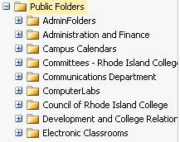
Click
The + sign next to the words
Electronic Classrooms

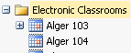
Click
The calendar next to the name of a classroom

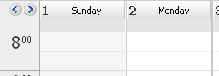
This will give you the dates and times and tell you if a room is being used.

(12) Favorite Queries

Queries are used to find summary data in PeopleSoft, such as enrollment in all department courses. The MIS department can create new queries for you if you know the data you want to show in the report. Contact Senior Programmer/Analyst in MIS Shalapyonok, Ludmila <LShalapyonok@ric.edu>

Reporting tools, Query, Query Viewer
On the left, bottom of the home page, click Reporting tools, Query, Query Viewer.

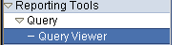

Enter your department name:
Example for Management and Marketing: “mgttech”

Semesters are:
sem # session sem # session sem # session
F11 = 1118 1 F12 = 1128 1 F13 1138 1
S12 = 1122 1 S13 = 1132 1 S14 1142 1
SU12 = 1126 6W1/6W2 SU13 = 1136 6W1/6W2 SU14 1146 6W1/6W2

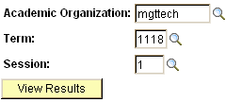
For many queries, you will be asked your department name and the semester.

Search for a query.
Reporting tools; Query; Query Viewer;

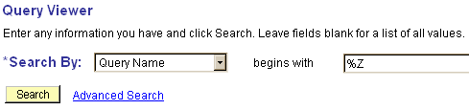
To see a list of all queries:
type %Z in the box

Add a query to your “favorites” so you don’t have to search for it again.

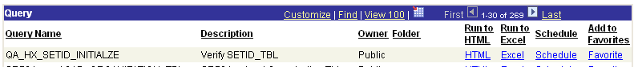

Here is a list of favorite queries.

Enrollment by department and semester
ZRSR_DEPT_SEM_CLASSES_DAY | Department Class Listing | • Dept classes and enrollment with schedule & professor
ZRSR_DEPT_SEM_CLASSES_DAY_A | Department Class Listing | • Dept classes and enrollment with schedule & professor
ZRSR_CMT_OPEN_AND_CLOSED_CRSE | CMT OPEN AND CLOSED COURSES | • SOM classes and enrollment
Advisors & students
ZRSR_STUDENTS_WITHOUT_ADVISOR | Students Without Advisor | • Students by dept without advisor
ZRSR_UAD_ADVISEE_LIST_BY_ADVIS | Advisor Advisee List by Advisr | • Students by dept by advisor name - one advisor at a time
ZRSR_UAD_STUDENTS_WITH_ADVISOR | Students with Advisor | • Students by dept with advisor, all advisor names on one page: for the secretary
Graduates: actual and pending
ZRSRR072_DEPT_GRADUATES_REP | Department UGDG Graduates RPT | • Students status for graduation by Records office for students with 100 or more credits
ZRSR_DEG_PUBLISH_HOME | Degree Recipients Potant&Comp | • Degree recipients
ZRSR_DEG_PUBLISH_MAIL | Degree Recipients Potant&Comp | • Degree recipients
Students enrolled in Majors
ZRSR_DEPT_ALL_MAJORS_MINORS_EM | All MAJ/MN not only under DEPT | • All dept students, including minors & double majors
ZRSR_DEPT_MAJOR_REP | Department Majors Report | • All dept majors
ZRSR_DEPT_MAJOR_REP_BY_PLAN | Dept Major Rep by Plan | • All dept majors, including MGT concentrations
ZRSR_DEPT_MAJ_GPA_IN_SUBJECT | Dept Major GPA within Subject | • All dept majors, with overall & dept GPA - used for graduation awards and for Honors program
Rosters
ZRSR_FACULTY_CLASS_ROSTER | Faculty Class Roster Enrl+Drop | • Roster for any course, including students who dropped the class
ZRSR_FACULTY_CLASS_RSTR_BY_CLS | Faculty Class Roster by Class | • Roster for any course
Who added students into courses
ZRSR_LABELS_FOR_COURSE | Labels For Course by Class Nbr | • Determine who added students into a particular course
ZRSR_ENRL_REQ_BY_CLASS | Enrollment Requests by Class | • Determine who added students into a particular course
Faculty workload report: for your own records
ZRIR_FAC_WORKLOAD_FORMS_DEPT | Instructor Workload data | • Faculty workload by classes taught
Check prerequisites
ZRSR_PREREQUISITE_CHECKING | Pre-requisite checking of Grd | • Check whether students have prerequisites for a course.

SECTION 2: STUDENT ISSUES

(1) Course Substitutions

Transcript notations.
Course substitutions are noted on the transcript “by hand” and never appear in the Academic Advising Report to meet graduation requirements and are never used by PeopleSoft as prerequisites.

Therefore, if a student substitutes something for a required course, then the chair will need to add the student into courses via PeopleSoft manually every semester.

If the student took the class at RIC.
Course Substitution form (8.5” x 5.5”)
http://www.ric.edu/recordsoffice/pdf/coursesubstit.pdf
Any course for your programs for students in your department.
Students in other departments must see their own chair.

General Education Course Substitution
http://www.ric.edu/recordsoffice/pdf/coursesubstit.pdf
Sent to chair of COGE, usually assoc. dean of arts & sciences (Joan Dagle).

If the student took the class at another college.
You can find the course numbers in the student’s Transfer Credit Report in PeopleSoft (see below). The Records office will not process substitutions for courses that are unrelated to your programs (e.g., you want to count a Philosophy course from anther college that shows as XFER 999 as a particular RIC philosophy course for a student with a Management major).

If the student took the class before coming to RIC, and student is in your dept.
Course Substitution form (8.5” x 5.5”)
http://www.ric.edu/recordsoffice/pdf/coursesubstit.pdf
It’s a nice courtesy to other departments to ask them to approve the course if
the course is in their major, but this is not required.

If the student wants to take the course at another college after enrolling at RIC.
Authorization of Credit form (8.5” x 11”)
http://www.ric.edu/recordsoffice/pdf/authorcreditform.pdf
If the course is in your dept., only you sign for all RIC students.
If course is in another dept., only that chair signs for all RIC students.

Transfer Credit Report.

In PeopleSoft, use the process you would use to find a student transcript. In the drop-down box, choose Transfer Credit Report instead of choosing Transcript.

Doe, Jane

Review the courses
Ask the student to bring to you a course description from the college. These can be obtained online. If the student has a syllabus, that can also be used to determine course equivalency. Substitutions are entirely at the chair’s discretion, but the chair can seek advice from other professors.

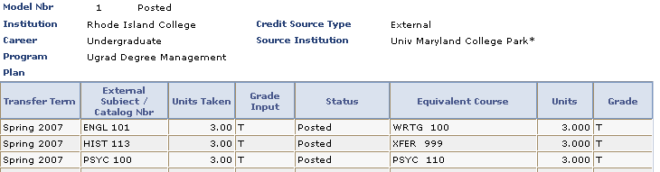
(2) Transfer Guide, RIBGHE

The Transfer Guide governs how courses transfer between RIC, URI, and CCRI.
http://www.ribghe.org/ritransfers.htm

Annual Meeting
Each May, the department chairs from the three public higher-ed institutions meet to agree upon which courses will transfer between the colleges. Because department chairs’ signatures control course substitutions within RIC for their majors, and control substitutions from other colleges for their majors, it is the department chairs who attend this meeting to make these decisions. The forms used at this meeting are printed to require only department chair signatures.

The contact person at RIBGHE is below. If you do not hear from her by April 15, send her an email to ask about the date, time, and location. For the last few years, the meeting was held in Alger 110.

Deanna Velletri
Rhode Island Office of Higher Education
Academic and Student Affairs
The Shepard Building
80 Washington Street
Providence, RI 02903
Phone 401-456-6010
Fax 401-456-6028
dvelletri@ribghe.org
www.ribghe.org

Transfer among CCRI, RIC, and URI
Transfer equivalencies among CCRI, RIC, and URI are given at http://www.ribghe.org/transfer11rev.htm

Bristol CC to RIC
There also is a Transfer Guide for Bristol Community College. http://www.bristolcc.edu/students/transfer/ta_agreements.cfm
(3) Class Search

General Education
In PeopleSoft, there are several search terms for “General Educ” courses. These do not work, so you need to search for specific courses, such as ANTH 161.

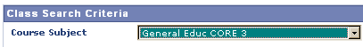

(4) Academic Advising

Find students to advise, and manage the number of students per professor (cf. article 10.22 of RIC/AFT contract).
To find all students in your department and all the advisors, use this Query.
ZRSR_UAD_STUDENTS_WITH_ADVISOR Students with Advisor

To find students who do not have an advisor (chair will need to advise them or give them an advisor) use this Query.
ZRSR_STUDENTS_WITHOUT_ADVISOR Students Without Advisor

To find students for a particular advisor, use this Query.
ZRSR_UAD_ADVISEE_LIST_BY_ADVIS Advisor Advisee List by Advisr

Create a one-page or two-page advising form
Sample advising forms
See samples at: http://www.ric.edu/managementMarketing/advising.php
For a version in Excel that you can modify for your department, send email to: scarter@ric.edu

Karen Rubino can create PDF versions of your forms, and put them on your department web site.
The advising form should include:
Required courses
Restricted electives
General education
Prerequisites
Free electives
Sample 4-year plan

Hold an advising meeting.
Obtain the Academic Advising Transcript.



Check the student’s progress in meeting requirements.
Check current semester enrollment
Check next semester enrollment (or student’s shopping cart)
Check Academic Advising section of transcript
General Education
Major Requirements
Minor Requirements
Unused courses (look for WRT 100)


Scan the first few pages of the transcript for notations
Chairs may have substituted courses, causing a notation.

Advise student on next steps
Choose classes for next semester.
Create tentative plan for future semesters.
(5) FERPA

FERPA (The Family Educational Rights and Privacy Act) is a federal law that protects the privacy of student education records.

From the Department of Education web site:
The Family Educational Rights and Privacy Act (FERPA) (20 U.S.C. § 1232g; 34 CFR Part 99) is a Federal law that protects the privacy of student education records. The law applies to all schools that receive funds under an applicable program of the U.S. Department of Education.

FERPA gives parents certain rights with respect to their children's education records. These rights transfer to the student when he or she reaches the age of 18 or attends a school beyond the high school level. Students to whom the rights have transferred are "eligible students." http://www2.ed.gov/policy/gen/guid/fpco/ferpa/.

If students wish to grant their parents access to educational records, the students must sign a waiver. At orientation, students who are new to RIC are offered the waiver option. Waiver forms also are available in OASIS.

Therefore, faculty must never release ANY academic information about a student to a parent without the student’s written permission. If parents contact faculty, the faculty should ask the parent to ask the student to use the RIC email address to send email to the faculty indicating the email address of the parent and that the faculty can share information with the parent.

Contact the Director of Records with questions/issues about FERPA. Also, see the following web sites:

http://www.ric.edu/recordsoffice/ferpa.php
http://www2.ed.gov/policy/gen/guid/fpco/ferpa/

(6) Majors and Minors

Advisors
Chairs often appoint advisors to students. Try to ensure that faculty each have about the same number of advisees.

Query for advisors
At the beginning of the semester, run the following query to determine how many students each advisor has. This will enable you to distribute the advisees fairly across the faculty.
Insert your department’s name
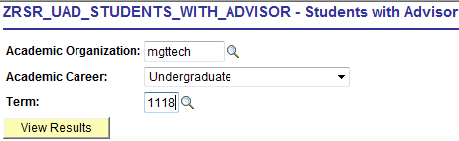

Query for students without an advisor
At the beginning of the semester, run the following query to determine which students do not have an advisor. Submit the form to Records to give each student an advisor

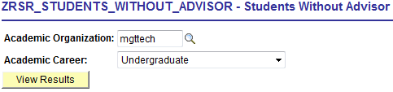

Minors
If your department offers a minor, you can run a query to determine if any students are enrolled in the minor.

ZRSR_DEPT_ALL_MAJORS_MINORS_EM All MAJ/MN not only under DEPT

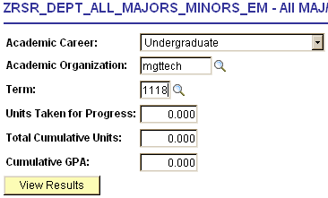

You can sort the spreadsheet by Program (i.e., school) and Acad Plan (i.e., major or minor).

(7) Add students into classes

Chairs may decide to add students into classes. To do so, follow these procedures:
Records and Enrollment → Enroll Students → Enrollment Request

.
Add this to your Favorites at the top, right hand of the screen

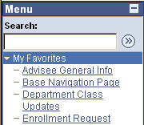
Click “Enrollment Request”
It will be added to your left hand menu, at the top

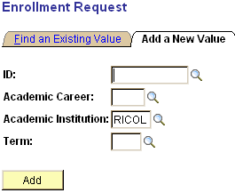
If you don’t know the student’s ID number, click the magnifying glass next to ID.

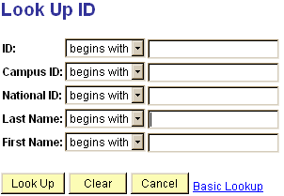
Enter the student’s name and click “Look Up.”


Click on the student’s name.

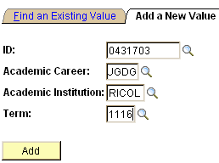
Type: UGDG.
Type: Term number, e.g., 1116

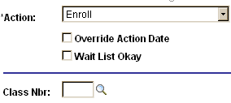
Action: choose whether to add, drop, or swap
Class Nbr: enter the 5 digit code or click the magnifying class, and search for a class.
Scroll to the bottom of the page. Check the appropriate boxes. If a class is locked by Records to prevent students from adding themselves (e.g., MGT 461) then you need to check the box next to “Permission Nbr.” You do not need to enter a number.

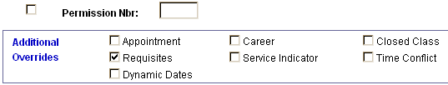

Click “submit” at the top of the page. If it worked, you will see the word “success”. If it did not work, scroll to the bottom of the page to see what kind of error message is given.

(8) Dropping a Class /“W” Grades

Students can drop a class via PeopleSoft until the midpoint of the semester. If they drop the class in the first two weeks, then no notation is made on the transcript. If they drop after the second week, the grade appears as a “W” grade.

If a student is a no-show in a class, professors should submit a “W” grade when mid-term grades are submitted.

If a student remains on the roster after the mid-term, then the professor should give the student a letter grade, not a “W” at the end of the semester. A student who has not completed the work is most likely to receive a failing grade. However, if a student has experienced extenuating circumstances and has completed enough of the course to have “substantial equity,” the professor can give an Incomplete, which must include an agreement between student and professor on a plan to complete the course. The grade of I will revert to an F if the grade is not changed after one semester.

For financial aid, students may have difficulties with financial aid if dropping the course changes their status to part time. Also, students might receive undeserved refunds in financial aid if they take a "W" at the end of the semester.

(9) Add / Drop Research: student & course enrollment history
Occasionally, you may need to conduct research to determine when students added or dropped courses or to determine who enrolled a student into a course. This occurs if a student is found to be enrolled in a course without prerequisites, and you want to know who added the student into the course. This situation may also arise if a student claims to have no knowledge of being enrolled into a course.

Student enrollment history
This will give you only the “add” or “enroll” transactions, not “drop” transactions.

Begin by following the steps to add a student to a class.
Records and Enrollment → Enroll Students → Enrollment Request

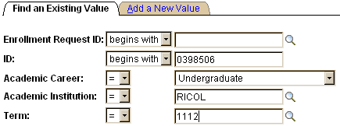
Click the tab for “Find an Existing Value”


Click
Search

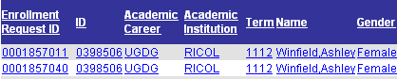
You will be given a list of transactions. Click on the top one.

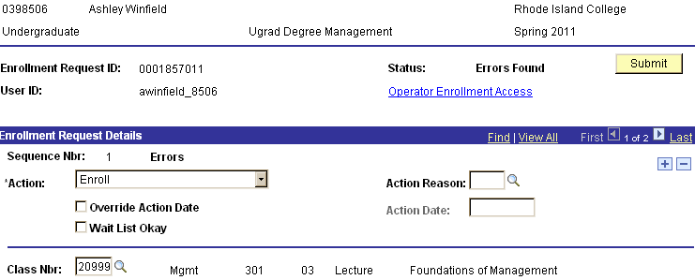
You will be given the enrollment transaction.
Enrollment Request ID is the transaction number.
It shows the transaction was “Enroll”.
It shows “Errors Found” meaning the student was not added.
It shows there was another transaction processed at the same time (1 of 2). Click the arrow next to the “2” to see the other transaction.

Scroll to the bottom of the page to see the type of “error.”

It shows the student did not have the “requisite” and it shows the date and time.

Scroll to the bottom of the page to see these buttons.
Click the button that says
Next in List.

This will take you to the next set of transactions for the student for the semester (i.e., the second blue text row from the previous page in this manual).

Course enrollment history
This will give you all add and drop transactions for a course.

There are two queries you can use.
ZRSR_LABELS_FOR_COURSE Labels For Course by Class Nbr

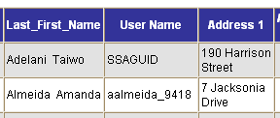
This query tells you only the adds.
It gives you the User Name (i.e., the name of the person who added the student to the class.
This query is useful if you have asked that no one else be allowed to add students into a class, so you can check to see if anyone but you or the students did so.

ZRSR_ENRL_REQ_BY_CLASS Enrollment Requests by Class
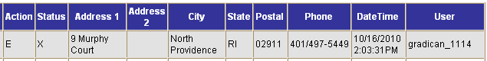

This query tells you the adds and drops.
Action:
E = enroll
D = drop
Status:
S = success;
X = error.
It tells you the User Name (i.e., the name of the person who added the student to the class).
It tells you the date and time.
This query is useful if you want to know when students dropped a course.

(10) Departmental Honors

http://www.ric.edu/honors/
Currently, Dr. Spencer Hall manages the honors program for RIC, and a faculty member in your department is appointed as the departmental honors liaison. Information regarding college and departmental honors should be on the department website.

If students are accepted into the Departmental Honors program, they will work with one professor on a year-long project, usually culminating in a thesis.

The department chair will need to sign to approve the thesis at its completion. The student will submit paper copies to the RIC Library, which will bind them into hardcover books. One of these copies should be returned to the department for department archives.

The department chair should ask Dennis McGovern in Records to create a course in PeopleSoft for the student’s thesis work.
The professor who supervises the thesis will be the instructor of the course. Faculty receive one (1) faculty load hour per semester.

The student will normally receive 3 credits per semester, but how these credits count in the major depends on your program. The chair may need to send a Course Substitution Form to Records for this.

After the student completes the thesis, the department chair should notify Records and Spencer Hall that the student should have “Departmental Honors” noted on the transcript.
(11) Departmental Awards
Graduation Awards
Every department has at least one award for undergraduates that is presented at Cap and Gown. If there is funding for this award, the funding is administered by the Foundation Office, Roberts 111 ("Iovini, Susan" SIovini@ric.edu); ("Hanrahan, Cathy" CHanrahan@ric.edu).

Graduation Query
If the award is based on GPA, as most are, you may need to run a graduation query to determine which students are eligible.
See Graduation query / list of graduates
ZRSRR072_DEPT_GRADUATES_REP - Department UGDG Graduates RPT
This query will give you a list of seniors and their graduation status.

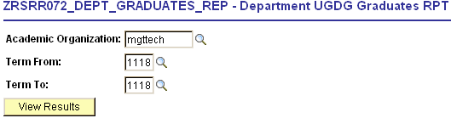
Type:
department name (yours)
semesters (current number)
You must obtain data for multiple semesters.

You will be given a list of students. You must run the query for the Fall through Spring semesters (e.g., from 1118 to 1122 = Fall 2011 to Spring 2012).

To download the report into Excel, click “Excel Spreadsheet:


The column you want to review is Cum GPA. Sort the rows by Major (Plan) and by Cum GPA.
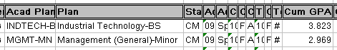

Alumni Awards
The Alumni Office will send you material on criteria to choose awardees and forms for submitting alumni personal and professional information.

One student should be chosen for each major. The student should have graduated at least 5 years ago. Ask members of the department to suggest names. If no names are suggested by the department, then ask the Alumni Office for suggestions.

Scholarships
http://www.ric.edu/foundation/endowed_eAannual.php
If there are scholarships associated with your department, as chair, you will need to make sure that students are chosen for the awards.

(12) Graduation

Applying for graduation
Students should apply for graduation via PeopleSoft (RIConnect) in the semester before they want to graduate (i.e., apply in the fall for spring graduation). This enables problems to be caught early so students can take the courses they need.

Students are assigned a contact person in Records when they apply for graduation. This person manages the substitutions and program adjustments for the student.

The contact people in Records are assigned as follows:

Students whose last names begin with the letters A – K: "Riley, Teresa" <TRiley@ric.edu>.
Students whose last names begin with the letters L – Z: "Shumate, Janet" <JShumate@ric.edu>.

If substitutions are made in the student's final semester, they should be sent directly to Terry and Janet.

Graduation query / list of graduates
ZRSRR072_DEPT_GRADUATES_REP - Department UGDG Graduates RPT

This query will give you a list of seniors and their graduation status.

Type:
department name (mgttech)
semesters (1118)
You can obtain data for multiple semesters.

You will be given a list of students. You can search for one semester (1118) or for multiple semesters.
To download the report into Excel, click “Excel Spreadsheet:

The column you want to review is ChkoutStat. This tells you the students’ graduation status: Applied (i.e., they applied in PeopleSoft); In Review (i.e., Records is evaluating it); Pending (i.e., they need to pass courses this semester; Denied (i.e., they are not taking their final required classes this semester).
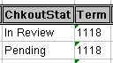

(13) Second Degree Students

http://www.ric.edu/admissions/admission.php
Occasionally, people who already hold a bachelor’s degree wish to earn a second bachelor’s degree. At the time of application for a second undergraduate degree at Rhode Island College, students must have completed a baccalaureate degree from a regionally accredited institution with a minimum cumulative grade point average of 2.0 (3.0 for Nursing and 2.7 for Radiologic Technology applicants). Previous college course work must be comparable to coursework currently taught at Rhode Island College.

Candidates for a second degree must successfully complete a minimum of 30 credit hours at Rhode Island College. Some programs, such as elementary education, may include over 90 credit hours, depending upon the student’s first undergraduate major.

In those areas where an advanced degree is offered, approval by the department chair and divisional dean is required for admission under the provision of the second-degree program policy. Admission to a second bachelor's degree program does not guarantee admission to those programs with a secondary admission process (i.e. education, nursing, social work).

Once all materials have been received and processed, the Admissions Office will notify the appropriate department chair/advisor and the student. At that time, the student must make an appointment with the advisor to discuss the program of study and to complete an official Plan of Study.

The Plan must include a minimum of 30 credit hours to be completed at Rhode Island College, at least 15 of which must be taken in the department of the major. In addition, at least 21 of the credits included in the Plan must be completed as a degree student at Rhode Island College.

SECTION 3: FACULTY ISSUES

(1) DAC

Article VI (RIC/AFT 1819) regarding Departmental Advisory Committees
http://www.ric.edu/ricaft/pdf/ricaftagreement07_10.pdf#page=16
This article describes the relationship of the chair to the DAC.

Structure of the DAC
6.2 Department faculty determine the size, structure, and method of selection of departmental advisory committees.

Duties of the DAC
6.3 The role of the departmental advisory committee is advisory. Its primary area of concern is personnel, including recommendations to the department chairperson on reappointments and non-renewals, salary increments, promotions, tenure, leaves of absence, and filling vacancies. In addition, the committee may be concerned with other departmental matters, including but not necessarily limited to:
a. departmental long-range planning
b. curriculum development
c. the department budget
d. recruitment of new faculty
e. scheduling and course assignments
f. improvement of instruction

Article 8.1 (RIC/AFT 1819) regarding Annual Review of Faculty
http://www.ric.edu/ricaft/pdf/ricaftagreement07_10.pdf#page=20
This article describes the role of the DAC in the annual review of faculty and in tenure/promotion decisions.

(2) Special Events

Chairs should recruit faculty to participate in the following events.

Summer
Orientation
Long-term program for new students. Faculty are paid for participating

Fall
Open house
Saturday event for people interested in applying for admission.

Spring
Graduate Studies Open House
One-day event in January for people interested in applying for admission.
Spring party
Saturday event for accepted students to meet with faculty.
Cap & gown
Last Wednesday of the semester, Free-Period, for graduating senior awards.
Commencement
Graduate (Thursday evening) and Undergraduate (Saturday morning)
Presidential Scholars dinner
March dinner for merit-based scholarship program that began in 2001 for qualified freshmen, awarding them $2,000 each year, renewable for four years, if they continue to meet eligibility requirements.
Alumni awards dinner.
May event for departmental alumni award winners.

(3) Class Roster

To obtain a roster for a course other than your own:

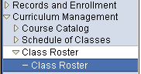
Curriculum Management
Class Roster
Class Roster

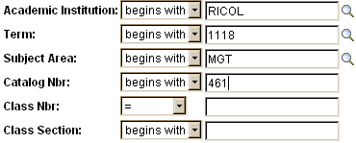
Type:
Term number
Subject area
Course Number
Click “Search”

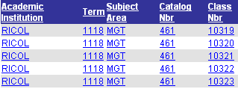
This will give you a list of the sections.
Click on the section you want.

(4) Book Orders
The chair can ask to approve faculty book orders, but this is not required. The chair might want to review choices of adjuncts, however.

RIC Bookstore Orders
Books for students at the RIC Bookstore can be ordered via email or via the Internet. To order via email, send the title, author, edition, and ISBN via email to: textbooks@ric.edu

To order via the Internet, follow the instructions below.


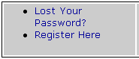
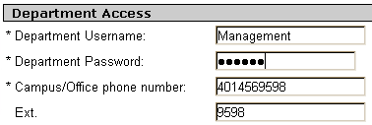
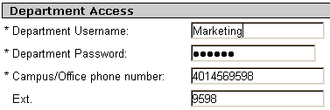
http://campusstore.ric.edu
At the bottom of the page, check the box for: "I have read and understand...”
Click blue button
"Faculty Adoptions"
Click: register here
Click: Create profile for Adopting Course Materials
Under: Faculty Registration, the password can be whatever you choose.
No spaces or dashes
Under: Department Access, enter the following
Department Password: ALG230
Steve and Henry should enter "Marketing" under Department Username.

(5) Building Schedules

The Process
The easiest way to build faculty schedules is to use the most recent schedule for the equivalent semester as a starting point and to ask faculty for changes.

First, run the query in PeopleSoft to obtain the Fall 2011 schedule. Next, download the schedule into Excel. Delete the names of adjuncts from courses so that tenure track faculty can have first choice of classes. Then, email the spreadsheet to faculty to ask for their input.

After making the changes in the spreadsheet that tenure track faculty have requested, you can inform the adjuncts of the staff classes and ask for their input and choices, but this step is not required. Instead, you can create the schedules for the staff classes, and then ask adjuncts whether they are available to teach the classes.

Run the Query
Reporting tools, Query, Query Viewer

Use one of these two queries to obtain a schedule
ZRSR_DEPT_SEM_CLASSES_DAY Department Class Listing Public ZRSR_DEPT_SEM_CLASSES_DAY_A Department Class Listing

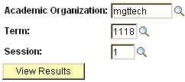
academic org: mgttech
term: code number
session: code number

click: Excel spreadsheet

Format the Spreadsheet
This is the left-hand side of the spreadsheet. You can delete the columns for Class Nbr, Term Session, Cap Enrl, Tot Enrl, Acad Org, and ID before sending the spreadsheet to faculty. If you don’t delete the columns, then change the column width to zero (0) in excel. Deleting or hiding these columns will make it easier for faculty to read the spreadsheet.

Class Nbr | Term | Ses sion | Sub ject | Catalog | Descr | Sec tion | Cap Enrl | Tot Enrl | Acad Org | ID | Name
10291 | 1118 | 1 | MGT | 249 | Stat II | 01 | 30 | 22 | MGTTECH | 111111 | Sahba,Nazanin

This is the right-hand side of the spreadsheet. Note that the days of class meetings are shown in 5 columns, with a Y (yes) if the class meets that day, and an N (no) if the class does not meet that day.

Mtg Start | Mtg End | Facil ID | Mon | Tues | Wed | Thurs | Fri | Prgrss Unt | Auto Enrol
8:00:00 AM | 9:20:00 AM | ALG105 | Y | N | Y | N | N | 3.00

The faculty will not be able to understand the schedule as it appears, so you will need to help them. To do so, insert a column after “Facil ID” and type the days when the classes will meet, as follows: MW, TTh, MTh, TF, or M, T, W, Th, F for one-day-per-week classes.

To add a column, in Excel, click the letter for the column for Mon to highlight the column, then on the Excel menu, click “Insert, Column.”

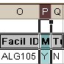

Update the Spreadsheet
Keep track of the changes faculty request in your copy of the spreadsheet. You can use colored text or colored cells to do so. At some point, Dennis McGovern will send you a copy of the schedule on paper, and you will need to make changes to Dennis’ paper schedule by hand. Keeping track of requested changes in your spreadsheet will make it easier for you to update Dennis’ spreadsheet, because he will send you the same spreadsheet you downloaded. Keep a photo copy of what you send to Dennis.

Submit to Records Office
A month or two after you submit the schedule to Dennis, he will send you a new paper copy. First, check this against your spreadsheet to ensure everything was updated correctly. Then, give Dennis’ schedule to faculty to have them double-check it. Make changes by hand, then resubmit to Dennis.

At some point, Dennis will ask you to visit the Records Office to double-check the Course Bulletin that will be mailed to students. Take your spreadsheet and the paper copy Dennis sent you to this proofreading session.

(6) Adjuncts

Adjunct Union Contract
The adjunct professors are not members of RIC/AFT 1819. Rather, they have their own bargaining unit, and their own contract with RIBGHE. http://www.ric.edu/ricadjunct/downloadContract.php

All RIC union contracts can be found on the website for the Human Resources department.
http://www.ric.edu/humanresources/policies.php

The adjunct union web site is here:
http://www.ric.edu/ricadjunct/

Assignment Based on Seniority
Full-time faculty have first priority for course assignments. The adjunct contract dictates that members of the adjunct faculty bargaining unit who have taught satisfactorily shall have the expectation of being assigned available courses according to availability, qualifications, and seniority. Every semester, the HR office will provide a spreadsheet with the adjuncts listed in order of seniority, which is determined by the number of credit hours taught at the college.

In order of decreasing seniority, beginning with the most senior adjunct faculty member in a given department, courses are assigned by the chair according to the adjuncts’ availability and qualifications. After one course has been assigned to each adjunct faculty in a particular department, the remaining available courses in that department are assigned by the chair, again in order of decreasing seniority, according to availability and qualifications.

Once per semester, an exception can be made in each department whereby the chair can assign a course to an individual with “special qualifications” and without regard to seniority.

The decisions of the department chair on adjunct assignments are not grievable.

The full language on adjunct assignment is on page 13 of the adjunct contract, http://www.ric.edu/ricadjunct/downloadContract.php

Promotion: Level Advancement
Adjunct faculty can apply for a “level advancement,” which enables them to earn a slightly higher salary for courses. The union contract contains details. The form for level advancement is at

http://www.ric.edu/humanresources/pdf/AdjunctApplicationFormforAdvancement.doc.

By March 15 in the spring and November 15 in the fall, adjunct faculty submit an application and documentation addressing the criteria for level advancement, which are teaching effectiveness defined in the same manner as for full-time faculty: teaching effectiveness, which include: command of the subject, skill in organizing and presenting course material with force and logic, intellectual integrity and enthusiasm for learning both within and without the classroom, ability to motivate students to intellectual curiosity, and specifics of actual teaching performance. The department chair should write a letter regarding the application and indicate their recommendation regarding the application on the form. The form and related documentation then go to the school dean.

Unsolicited Resumes
When an unsolicited resume arrives, you may need to notify the applicant of the current collective-bargaining situation. Following is a sample e-mail for this purpose:

Good afternoon, Mr. Smith,

I am writing in regard to the application for an adjunct faculty position that you recently sent to Rhode Island College. We appreciate receiving your application, and we believe your credentials are quite impressive.

The staffing process for adjunct faculty members is governed by the contract that their union, the RIC/AFT Adjunct Union, has with the Rhode Island Board of Governors for Higher Education (RIBGHE). This contract requires that we staff the courses based upon seniority of adjunct faculty members.

Although we may be unable to have you join us at this time, if our staffing needs increase in the future, we will contact you for an interview.

Thank you for your interest in teaching and Rhode Island College.

Sincerely,

Your name
Chair, XXX Department

(7) Faculty Workload forms
The Process
There are many steps to creating the workload records for faculty, to ensure they carry 12 credits per semester and to ensure they are paid via the Special Monthly Payroll. The first step is to add the professors’ names to classes if their names are not submitted with the original course schedule that is sent to Records (Dennis McGovern). The second step is to access their workload pages and to determine whether a course is in load or overload and whether the professor has other overload credits, such as prep credit, internship, assessment, etc. The third step is to submit their payroll via PeopleSoft.

Step 1: Add Faculty to Classes

RIC Custom Applications > RIC Management Center

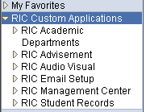
Click:
RIC Custom Applications
RIC Management Center
Click:
Department Class Updates
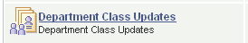

Type:
Term
Department name
Click:
Search
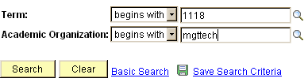

Click:
The magnifying glass next to the empty box to the right of the word “replace”
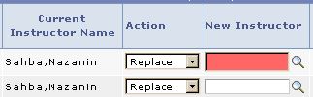

To change a class to “staff
Type eleven “9’s” in the box, instead of clicking on the magnifying glass.
99999999999

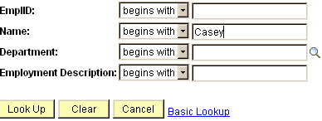
Type:
The name of a professor.
Click:
Lookup

Click:
The name of the professor.
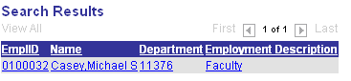

It will take you back to the first page and you will see this.

At the bottom, left of the page:
Click:
Make instructor assignments.
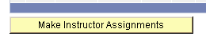

Step 2: Complete Workload Forms in PeopleSoft
At the beginning of each semester, you will need to update faculty records to ensure they receive credit for teaching 12 credits per semester, and to ensure they are paid for overload credits via the special monthly payroll (e.g., teaching an extra course, teaching more than two preps, or performing administrative functions).

You CANNOT submit workload for your own personal record; you can submit it only for your department faculty. Remind your dean to submit your workload.
On the left of the screen,
Click:
RIC Custom Applications



In the middle of the page
Click:
RIC Management Center


In the middle of the page
Click:
Maintain Term Workload


On the right of the page
Click the yellow button:
Maintain Workload for a professor.

This is the left-hand side of the page
Click drop down box under “Assign Type”
Choose the type of compensation:
STD - regular class
OVI - overload teaching (an extra course)
OVP - overload prep (more than 2 preps)
OVA - overload admin (e.g., assessment)
Ensure the number of credits is correct.

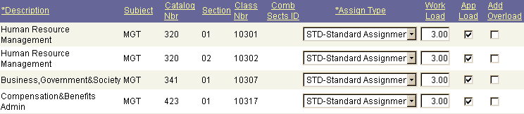

This is the right-hand side of the page.
You might need to add another row. This occurs if: the professor is teaching more than 2 preps; or the professor is receiving “release time” for research, assessment, or other duties.

To add a row, click the + on the right.

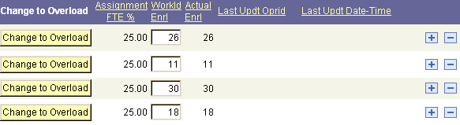

This is the left-hand side of the page
In the empty box, type the reason for the payment (e.g., extra pre, MGT 423)
Click drop down box under “Assign Type”
Choose the type of compensation:
STD - regular class
OVI - overload teaching (an extra course)
OVP - overload prep (more than 2 preps)
OVA - overload admin (e.g., assessment)
Ensure the number of credits is correct.

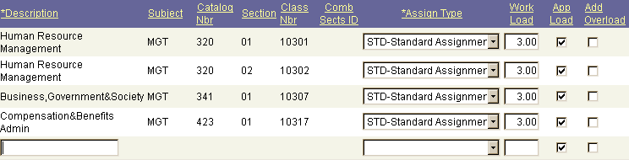

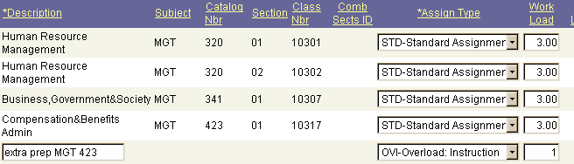

Review Your Work: Summary of Compensation

Before you submit the information to payroll, you should double-check your work.
This will give you a one-page summary of all the faculty overload compensation. The budget office may request this information.
RIC Custom Applications > RIC Management Center

Click:
RIC Custom Applications
RIC Management Center

Click: Payroll Contracts

Click: Instructor Contracts Report


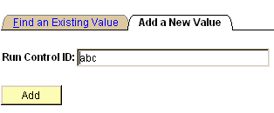
Click: the tab for Add a New Value
Type anything in the empty box (e.g., abc)
Click Add

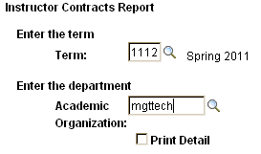
Type: semester and department name


Click: save


Click: run

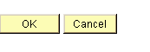
On the next page
Click: OK

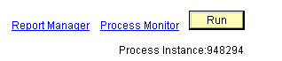
On the next page
Click: process monitor

On the next page
Click: refresh (yellow button) multiple times until you see the word “success”
Click: Details

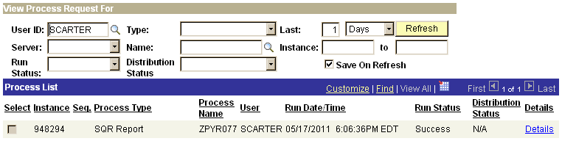

On the next page
Click: View Log/Trace

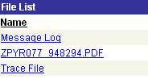
On the next page
Click: The word that starts with “Z”
(e.g., ZRYR077)

This will give you a one-page summary of the faculty overload compensation.
Review Your Work: Workload Details for Each Professor

Before you submit the information to payroll, you should double-check your work.
This will give you a multi-page report of the faculty overload compensation. There will be one page per professor.
Click: RIC Custom Applications
Click: RIC Academic Departments

Under: Reports

Click: Faculty Workload Forms-Dept


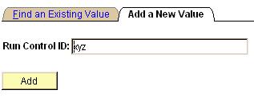
Click: the tab for Add a New Value
Type anything in the empty box (e.g., xyz)
Click Add

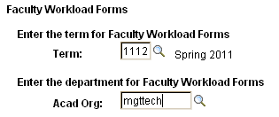
Type: semester and department name

Click: save

Click: run

On the next page
Click: OK

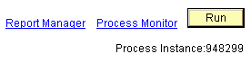
On the next page
Click: process monitor

On the next page
Click: Refresh (yellow button) multiple times until you see the word “success”
Click: Details

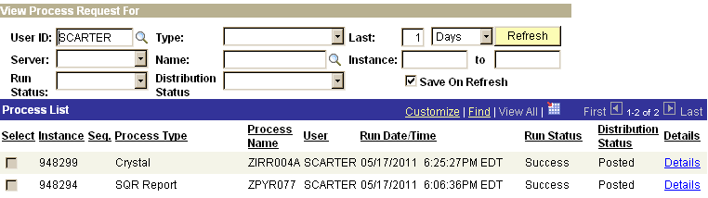
On the next page
Click: View Log/Trace

On the next page
Click: The word that starts with “Z”
(e.g., ZIRR004A)
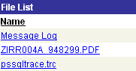

This will give you a multi-page report of the faculty overload compensation. There will be one page per professor. If you find a professor in your report who is NOT teaching in your department (or if one of you professors is missing), notify Dennis McGovern.

Step 3: Submit Payroll

Chair Compensation
You cannot submit workload or payroll for your own personal compensation. This must be done by your dean. It is a good idea to remind your dean at the start of each semester to do so; otherwise you will not be paid under Special Monthly Payroll for overload credits. In addition, ensure that you remind the dean on December 1 and May 1 to submit the paper multi-part form to payroll for you to be paid your chair stipend. You will receive your chair stipend for the semester in one lump sum at the time of the last Special Monthly Payroll of the semester (December 20 or May 25).

Faculty Compensation
After you complete the workload for each professor, you will need to submit their payroll contracts via PeopleSoft. This process replaces the multi-part forms that used to be typed each semester for Special Monthly Payroll.


Click: RIC Custom Applications


Click: Submit Instructor Contracts

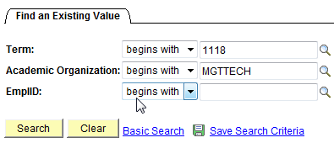
Type: semester, department
Click: Search

You will be given a list of all faculty in the department.
Click a faculty name.

Review the information for the professor and
Click: Submit for approvals. This sends the payroll record to the dean, who will approve it and send it to the VPAA.

To obtain a copy of the contract
Click: Report Manager.

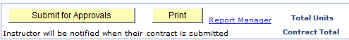
(8) Annual Reviews

The Process
Annual reviews of faculty are conducted on a calendar year basis. In November, faculty submit a self-report (Personal Data Form) to chairs. After the end of each semester, chairs receive student evaluations of teaching from MIS. Chairs consult with the DAC, and write their evaluations on the Annual Faculty Evaluation and Recommendation Form that they receive from Human Resources. The Annual Faculty Evaluation and Recommendation Form is signed by the chair and the faculty member and submitted to the Dean by early February.

Criteria
The RIC/AFT 1819 contract stipulates the criteria that should be used to evaluate faculty.

Teaching effectiveness
Command of the subject,
Organizing and presenting material with force and logic,
Intellectual integrity,
Enthusiasm for learning both within and without the classroom,
Ability to motivate students to intellectual curiosity,
Class visits by the department chair, faculty peers, and occasionally by the appropriate dean, and
Evaluations by students.

Professional competence
Research, publication, grants, or creativity and performance in the fine arts,
Leadership and service to the College,
Professional improvement,
Leadership and service to the community, state, or nation.

Documentation
Peer Observation/Classroom Observation Report
Each department should have a document that allows faculty to document their observations of each others’ teaching. In some departments, each professor is visited once every fall by one other professor. The document is submitted to the chair as part of the annual review.

Student Course Evaluations
Each department should have documents that students complete anonymously to evaluate teaching. The documents can be multiple-choice, bubble forms, and/or open-ended questions. Untenured professors should be evaluated in every course. Tenured professors should be evaluated in at least one course per academic year.

Faculty Personal Data Form
Each November, each professor will need to submit a Personal Data Form to the chair.

Other Documentation
Faculty also can submit their vita, publications, and other documentation of their work to the DAC and the Chair.

(9) Recruiting faculty

The Process

Article VII of the RIC/AFT Contract defines the initial appointment process, the ranks, and the standards for each rank. See http://www.ric.edu/ricaft/pdf/ricaftagreement07_10.pdf#page=17.

The Search Committee Guide for Faculty Hiring, http://www.ric.edu/academicAffairs/pdf/SearchCommitteeGuide.doc, gives information on:
- Timeline for searches
- Search committee composition and work
- Recruiting strategies
- Campus interviews
- Hiring
- Confidentiality and other legal issues

Associated forms are available http://www.ric.edu/academicAffairs/facultyresources.php.

In short, the first step is to submit a request and justification for the position to the dean. The second step is to create the job description. The third step is to create the advertisement. The fourth step is to have the search committee screen applicants. The fifth step is to interview selected applicants. The sixth step is to submit a name for hire to the administration.

At each step, the dean and Human Resources (Janine Tegu, JTegu@ric.edu; and Sandy Langlois, SLanglois@ric.edu) are involved to some extent. For Human Resources, there are several Affirmative Action forms (monitoring reports) you must complete. HR will send these to you. Ensure that you complete these in a timely manner, because you cannot move to the next step in the process (e.g., from reviewing applications to conducting interviews) until you submit the forms to HR.

In addition, you will need to manage the process in PeopleAdmin, the online system where applications are submitted and reviewed by the committee. As chair, you will have access to the applications. You sign on to PeopleAdmin via a different sign-on page than is used by applicants.

https://employment.ric.edu/hr

HR will give you this information. You must not review any material that is not included in PeopleAdmin. If an applicant sends extra material via email or paper, inform the applicant that the material must be loaded into PeopleAdmin and that the person should contact HR if assistance is needed.

Step 1: Submit a Request
Create a justification for the position. This can be based upon the loss of a faculty member, high enrollment, etc. The justification can be a narrative, and eventually will be summarized into a spreadsheet. Some examples are shown below from the 2010-2011 academic year.

“Justification for Filling Position:
Replacement of faculty member in high-enrollment, moderate growth, adjunct-dependent area.
On September 20, 2010, there were 509 management majors and 27 minors. There are 8 full-time participating management faculty, including one on phased retirement. The faculty/advisee ratio was almost 63:1 (72:1 if not considering the member on phased retirement). Additionally, the impending HCA and new the Radiology Tech majors will add stress to current capacity as several management courses are part of the these two programs. In addition, the psychology graduate program allows students to make use of some management courses.”

“Impact on Department if position were not filled:
We will be unable to offer a sufficient number of courses for students to graduate. In
addition, we will have an insufficient number of faculty to provide academic advising to students. We also will have an insufficient number of faculty to provide committee members to the department, to the School of Management, and to Rhode Island College.”

School | Tier  1=  high, 2=  moderate, 3=  low | Department | Specialty Rank Appointment  (e.g. Assistant Professor) | Status of Existing or Previous Position | Position Type | Justification  (May include number of majors over last three years, total number of students taking courses in this area, number of sections taught by adjuncts in this area, strategic development of new area, other arguments about the criticality of the need)
SOM | 1 | Management and Marketing | Management, Assistant Professor | Phased retirement (Halil Copur) coming to an end | tenure track | Replacement of faculty member in high-enrollment, moderate growth, adjunct-dependent area.
SOM | 2 | Management and Marketing | Management, Assistant Professor | New Position (Open position from several years ago never filled) | tenure track | In Fall 2009, there were 399 management majors and 27 minors. There are 8 full-time participating management faculty, including one on phased retirement. The faculty/advisee ratio was almost 50:1 (57:1 if not considering the member on phased retirement). Additionally, the impending HCA major will add some stress to current capacity as several management courses are part of the HCA program.

Step 2: Create the Job Description.
Use the existing template (ask HR for a copy), and make changes based upon the courses you would like the professor to teach.

Step 3: Create the Advertisement.
Advertisements are placed in the Chronicle of Higher Education. If more than one position from your school is being advertised, the positions for that school will be placed in a group advertisement. There should be a statement about when applications are due (i.e., firm deadline; priority to applicants who submit by a certain date; or open until filled).

Example of Chronicle advertisement

Rhode Island College
School of Management
Anticipated Vacancies - Fall 2011
(Pending Budgetary Approval)
Final appointments are subject to available funding

The School of Management (SOM) at Rhode Island College is a student-centered, continuously innovative, high-technology business school. Approximately 1,100 students major in undergraduate programs in Accounting, Computer Information Systems, Economics, Finance, Marketing, and Management (with concentrations in Human Resource Management, International Management, Operations Management, and General Management); and a master’s degree program in Professional Accountancy. Valuing high quality teaching and scholarship, the SOM is currently seeking AACSB accreditation. The SOM has an extremely collegial and dedicated faculty, award-winning student organizations, exemplary internship program, energetic Advisory Board, state-of-the-art facilities in a newly renovated building, and is supportive of faculty development.

The SOM is located on a 180-acre suburban campus on the outskirts of historic Providence, R.I., cited by MSN as one of top ten places in America to live, and named "Most Improved City" in the nation. The region features superior education, recreation, culture, and quality of life, with easy access to marine, bucolic, and metropolitan amenities (including Boston and New York).
The School of Management at Rhode Island College invites applications for the following full-time positions at the rank of Assistant Professor, for Fall 2011:

Management and Marketing: Management (Strategy). Tenure track position. Teach undergraduate courses in Strategic Management and occasional courses in Operations Management. Required: Ph.D. or D.B.A. in Management; evidence of meritorious academic and teaching accomplishment.

IMPORTANT: Priority given to applicants who apply by December 31, 2010. For full job descriptions, which include additional responsibilities and requirements for the positions and application procedures, see our web site at https://employment.ric.edu/

Candidates must apply on-line, using Rhode Island College’s PeopleAdmin Applicant Tracking system.

The doctoral or other appropriate terminal degree is required for all tenure-track appointments and must be completed prior to the beginning of service.

As an Affirmative Action/Equal Opportunity institution which values and is committed to expanding the diversity of its faculty and staff, the College invites members of protected classes, including minorities and persons with disabilities, to identify themselves as such at the time of application. www.ric.edu

Step 4: Review Applicants.
Review the applications and note the following credentials. HR will tell you if a candidate has self-identified as a minority. You can use the spreadsheet to keep track of whether to interview candidates and when you have contacted them.

Candidate | Degree | University | Teaching | Research w/o conf | Service | Experience | phone | email | minority

Step 5: Interview Applicants.
The search committee may call the applicants in their top tier to ask if they are still interested in the position. Tell them the teaching load (4 classes) and the maximum possible salary that has been approved. This helps screen applicants who are not interested in teaching at our type of institution.

Reimbursement
For the applicants you are going to interview, RIC will pay airfare from within the continental 48 states and one night in a hotel. If airline schedules will make one night impossible for the candidate, you may be able to obtain permission for two nights in a hotel. The candidate must pay for the airfare and then seek reimbursement from RIC. The hotel bill is paid directly by RIC. Meals are paid by candidate if the candidate eats alone (e.g., breakfast) or the department chair if RIC faculty are present (e.g., lunch) and reimbursed by RIC.

Hotel
Ask Pam Sisto or Deborah Iannuccilli (DIannuccilli@ric.edu) for help in reserving the hotel. The room must be reserved by the budget office, because the college has agreements with several local hotels and does not pay taxes.

Interview day schedule
The candidate should have a schedule resembling the following. Email a copy of the schedule and the candidate’s vita to Pam and she will create a folder for DAC members to sign up. The schedule can be longer if DAC members want to meet the candidate later. You can include dinner, but often, candidates prefer to have the down time.

Date 15-Feb
Time Candidate name
9:00 Breakfast
9:30 Campus Tour
10:00 Campus Tour
10:30 VPAA
11:00 Dean
11:30 Lunch
12:00 Lunch
12:30 Presentation
1:00 Presentation
1:30 Presentation
2:00 Faculty
2:30 Faculty
3:00 Faculty
3:30 Campus Tour

Structured Interview Questions
HR requires that we use a structured interview, and that all candidates be asked the same questions. In addition, HR requires there be no one-on-one interviews between the candidate and faculty. Ensure that all search committee members have a copy of the list of questions. The questions should be used during the applicant’s presentation.

(sample questions)
- Our student body has a wide range of ability and motivation. How does your teaching philosophy fit with this? Can you give us an example?
- What subject do you enjoy teaching most?
- What mix of assignments in classes and how do these vary across introductory and upper level classes?
- We have a writing requirement. What kinds of writing assignment would you have in class?
- Can you teach courses X, Y, and Z?
- How do you engage students in classroom to be sure all student voices are heard?
- Describe a typical day in class.
- How do you envision technology being used in your classes?
- When a student is graduating and leaving, what advice do you have for the student?
- What do you think students expect from you and what do you expect from them?
- You’ve had a chance to review our curriculum. What contribution would you like to make to improving or updating our curriculum?
- We usually teach 12 credits per semester with expectations to conduct research without doctoral students. What type of research do you have planned that can be achieved in this environment?
- How do you see your dissertation or other current research carrying forward for future research and publications?
- What are your next steps for research?
- How would you obtain assistance or feedback on your research to prepare it for publication?
- Where do you see yourself making a contribution in terms of service at the department and college level. What committees would like to join, such as curriculum student groups, etc.?

Step 6: Submit a Name for Hire and Recommended Salary to the Administration.
http://www.ric.edu/humanresources/pdf/Offer-Appointment%20Form%20Revised%201-7-2011.pdf
After the department decides to make an offer, complete the Offer/Appointment Form with a recommended salary to the dean. After the dean obtains approval from the VPAA and president, the dean or search chair will call the candidate to make an offer. If the candidate contacts you in the meantime, you can tell the candidate that s/he is very high on the list.

Section 4: Bibliography

Thematic, Barely-Annotated Bibliography for the ADE New Chairs’ Workshop
compiled over the years by
Wendy Moffat, Maureen Reddy, Irwin Weiser, John Zomchick,
Katherine Rowe and William Rivers

(Note: Some of the Chronicle URLs may have changed. Articles can still be accessed by searching for name of article.)

General Resources
ADE Bulletin with searchable index: http://www.ade.org/bulletin/index.htm

ADECH-L. The chair’s discussion list, moderated by David Laurence. This is a fairly low-volume, but very useful resource. If you’re not subscribed, contact David.

ACE Department Chair Online Resources Center. American Council on Education has a web site with resources for Department Chairs, which can also serve as a reference for new chairs. It features an annotated bibliography, with sections “The Chair as Leader,” “The Chair and Faculty,” “Resource Management,” etc. http://bit.ly/mBqj0c.

The Department Chair. A quarterly publication from Jossey-Bass. Here’s the blurb from the website: “A unique resource for chairs, deans, academic vice presidents, and other administrators, The Department Chair delivers practical information in every issue. Written by practitioners from their own experience, this publication is invaluable to anyone responsible for a department in any institution of higher education” (http://www.departmentchairs.org/publications/3-2.).

Donoghue, Frank. The Last Professors: The Corporate University and the Fate of the Humanities. New York: Fordham UP, 2008

Menand, Louis. The Marketplace of Ideas. New York and London: W. W. Norton, 2010.

Newman, Frank, Laura Couturier, and Jamie Scurry. The Future of Higher Education: Rhetoric, Reality, and the Risks of the Market. San Francisco: Jossey-Bass/Wiley. 2004.

David Laurence (DLaurence@mla.org). Any pickle you are in he has likely seen in some iteration; he can offer sage advice or direct you to other chairs for advice and creative solutions.

The Business of Chairing
Baron, Dennis. “Around the Clock,” http://bit.ly/kcpK5t. A not entirely tongue in cheek description of a department chair’s day, hour by hour.
----- “Learning to be a Department Head.” The Chronicle of Higher Education. http://bit.ly/jC71LU
-----“Sharing Inside Information: When Should Department Heads Keep Faculty in the Dark,” http://bit.ly/kNXPhw
Cresswell, John W. The Academic Chairperson’s Handbook (Lincoln: U Nebraska P, 1990). NOT DATED; a good primer and overview
Diacon, Todd A. “Is It Really That Tough?” The Chronicle of Higher Education. http://bit.ly/j9OU21
Dickeson, Robert C. Prioritizing Academic Programs and Services: Reallocating Resources to Achieve Strategic Balance. Jossey-Bass, 1999. Are you curious about what the upper administration is thinking? Here’s a book that gives you some insights into theories and practices for resource reallocation.
Fish, Stanley. “The Golden Rule.” The Chronicle of Higher Education http://bit.ly/jzU9PZ
-----“Real Meetings” http://bit.ly/kAeSO3
-----“You Probably Think This Song is About You” http://bit.ly/mDMWwv Diagnosis for determining if your department is unhappy.
Gmelch, Walter H., and Val D. Miskin. Chairing an Academic Department. Thousand Oaks, CA: Sage, 1995. Still very useful.
Gunsalus, C. K. The College Administrator’s Survival Guide. Cambridge: Harvard University Press, 2006. Especially useful in learning to deal with difficult faculty.
Hecht, Irene W. D., Mary Lou Higgerson, Walter H. Gmelch, and Allen Tucker. The Department Chair as Academic Leader. Phoenix, AZ: Oryx, 1999.
Jenkins, Rob. “What New Department Chairs Need to Know.” http://bit.ly/jCM2sY
Moffat, Wendy. "Marketing the English Major, Or Tending the Garden, Organically." ADE Bulletin 281: Spring 2001, 25-31. On building department community through ascertaining the department’s strengths.
Munger, Michael C. “10 Suggestions for a New Department Chair.” http://bit.ly/iJuiUb
Olson, Gary A. “What Deans Expect of Department Heads.” http://bit.ly/l7tKvS
Reiter, Howard L. “Advice to a New Department Chair.” http://bit.ly/lIhB4g
Sternberg, Robert J. ed. Why Smart People Can be So Stupid (New Haven: Yale UP 2002), esp. Carol S. Dweck’s “Beliefs That Make Smart People Dumb. ” Some wonderful articles on the psychology of mismanagement.

Special Issues in Effective Chairing
ADE Ad Hoc Committee on the Status of African American Faculty Members in English
The writers of this recent report gathered useful insights into the special problems for all minority scholars. http://www.ade.org/reports/index2.htm

Becker, Carol. “Trial by Fire: Gender and Leadership.” http://bit.ly/lqEJRS
Freeman, Sue. Women on Power: Leadership Redefined (Boston: Northeastern U P 2001)
McClain, Lee Tobin. “Lessons in Time Management: For New Assistant Professors, the Most Difficult Challenge is Learning How to Set Priorities,” http://bit.ly/jNTJF9
Rowe, Mary P. “Micro-Affirmations and Micro-Inequities.” Journal of the International Ombudsman Association, 1:1, March 2008. http://bit.ly/kZnCHc
Wilson, Robin. “Singular Mistreatment: Unmarried Professors are Outsiders.” http://bit.ly/k1rRYL

Teaching
Best, James L. Teaching Well and Liking It: Motivating Faculty to Teach Effectively. (Baltimore: Johns Hopkins UP 1997), esp. Stephen A Stumpf and Violina R. Rindova “Assessment and Evaluation Techniques,” 268-284.
Pedagogy: Critical Approaches to Teaching Literature, Language, Composition and Culture (Duke); Journal devoted to practical and innovative strategies for good teaching

Useful Polemics on the State of Higher Education
Bosquet, Marc. How the University Works: Higher Education and the Low-Wage Nation. New York and London: New York UP, 2008.
Readings, Bill. The University in Ruins. (Cambridge: Harvard UP, 1996)

Miscellaneous On-line Resources
http://counsel.cua.edu/how.cfm (This is Catholic University’s guide to legal issues affecting academic institutions.)
http://www.insightassessment.com/cases.html (A set of fictional case studies and some on-line workshop activities for chairs, deans, and other administrators.)

